A Tribute to Les Murray
(1938-2019)

presented by WA Poets Inc and the Centre for Stories

Friday 10 May, 6-7pm
Centre for Stories, 100 Aberdeen St, Northbridge

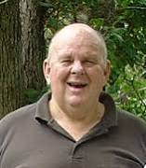(winner of the Grace Leven Prize, the Petrarch Prize,
the T S Eliot Prize,
the Queen’s Gold Medal, amongst other awards)

Dennis Haskell, Memories of Les

The poetry and essays of Les Murray, read by WA poets:
Lucy Dougan
Gary de Piazzi
Rose van Son
Robert Wood
and Les Murray (via Facebook)

